1.

Relational Tables:

client (company_name, address, phone, email, fax, linkmman)

project (code_name, in_date, com_date, budget)

technologies (tech_name, fir_date, used_cnt)

employee (e_ID, e_name, hire_date, position, salary)

uses (code_name, tech_name)

order (company_name, code_name)

workon (e_ID, code_name, percent)

isprofficientin (e_ID, tech_name)

EER_Diagram:

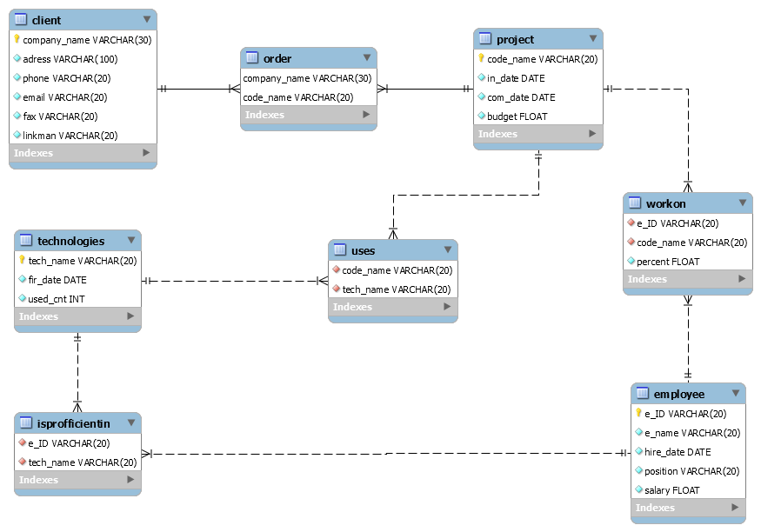

Difference: The DDR daigram generated by the SQL code will display the data type of the attributes in the table and the performance of one-to-one, one-to-many, and many-to-many is different

2.

Relational Tables:

agent (at_name, employment, at_phone)

agency (acy_name, acy_address, acy_address)

property (list_#, list_date, sale_price, cnt_bathroom, cnt_bedroom, car_fit, seller_name, footage, age, cnt_floor, list_address, type, )

tranfer (tran_price, tran_price, tran_date, buyer_name, list_#, acy_name)

sale (list_#, acy_name, at_name)

work_on (at_nmae, acy_name)

ER_Diagram

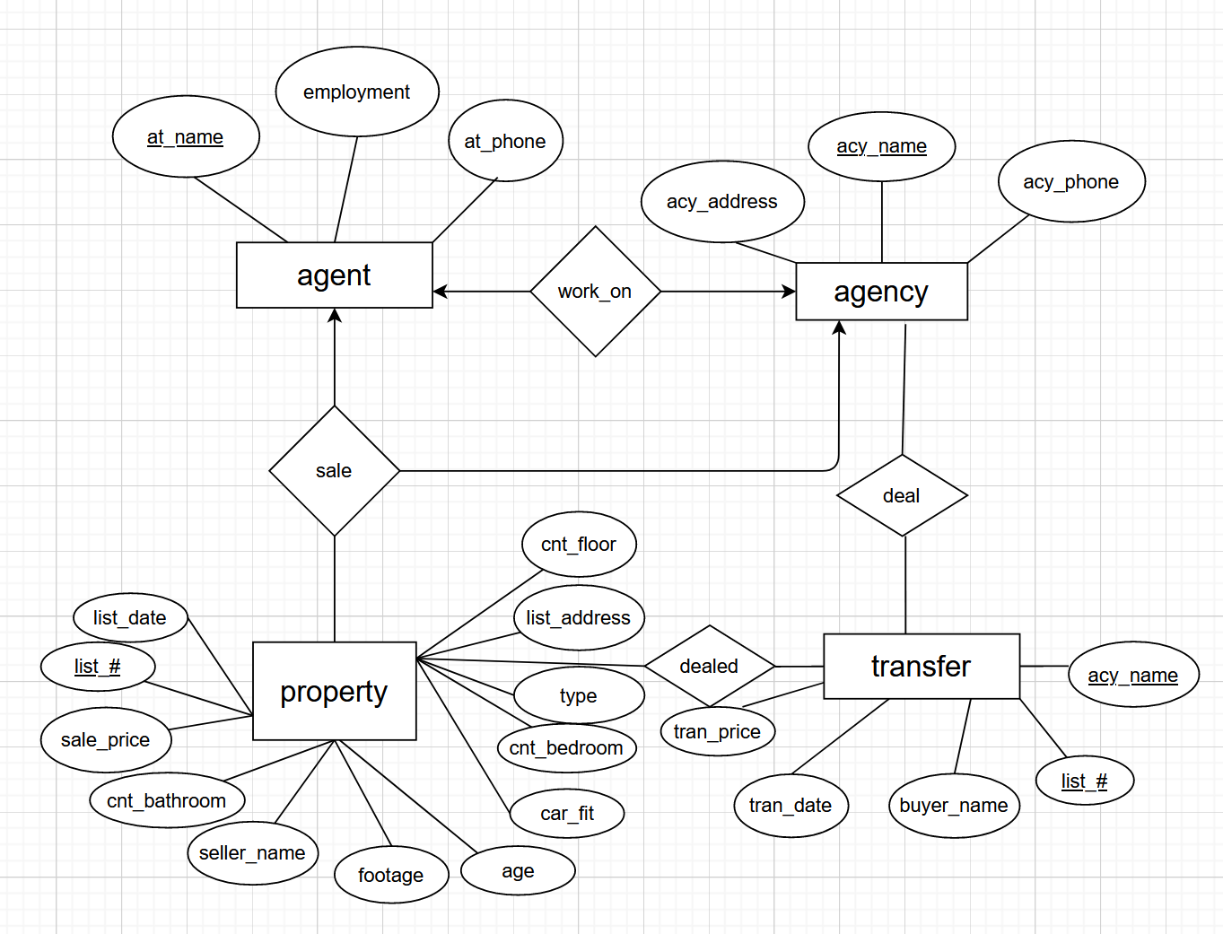

**HistorySale**

EER_Diagram

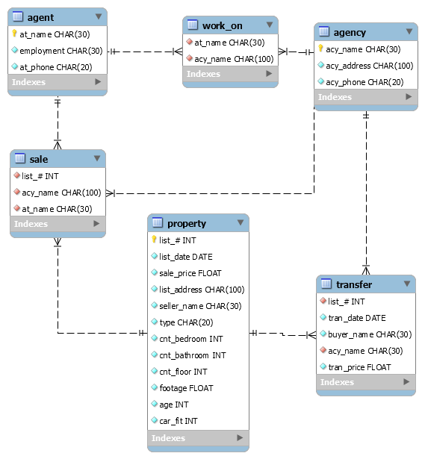

Different:

There are no relation table between the table “tranfer” and table “property”, and the relationship between the table “tranfer” and table “agency” in EER Diagram which is generated. And there are “deal” and “dealed” two relation table between the table “tranfer” and table “property”, and the relationship between the table “tranfer” and table “agency”.